[E137] Check valve

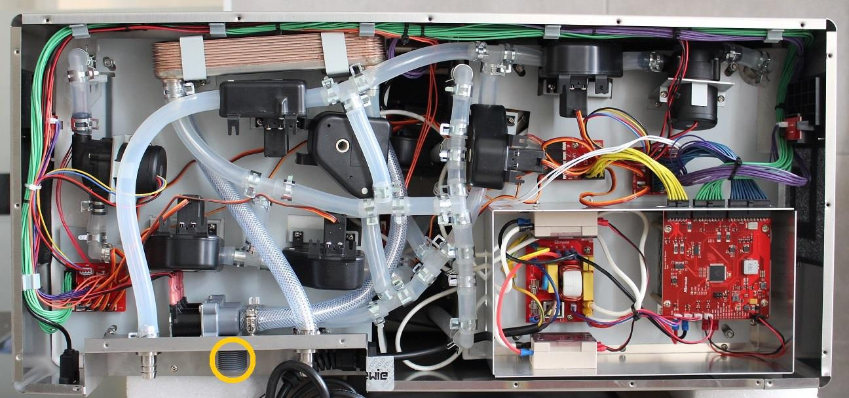

The check valve is located in the inlet of the high pressure valve.

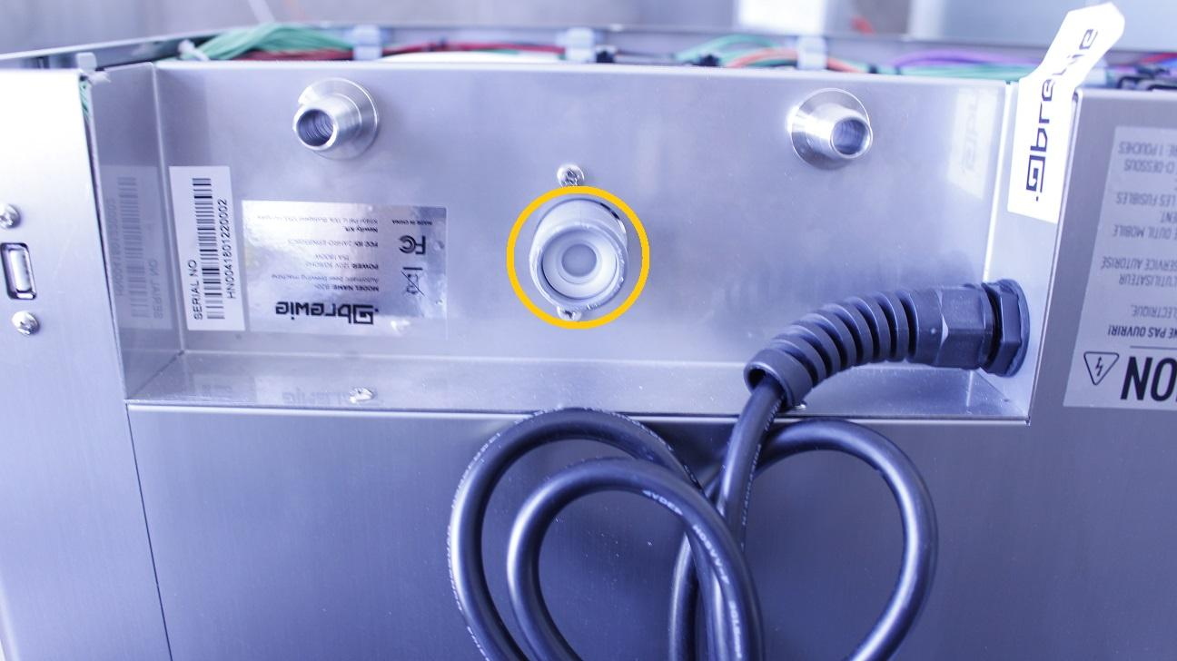

Pull out the check valve by a plier.

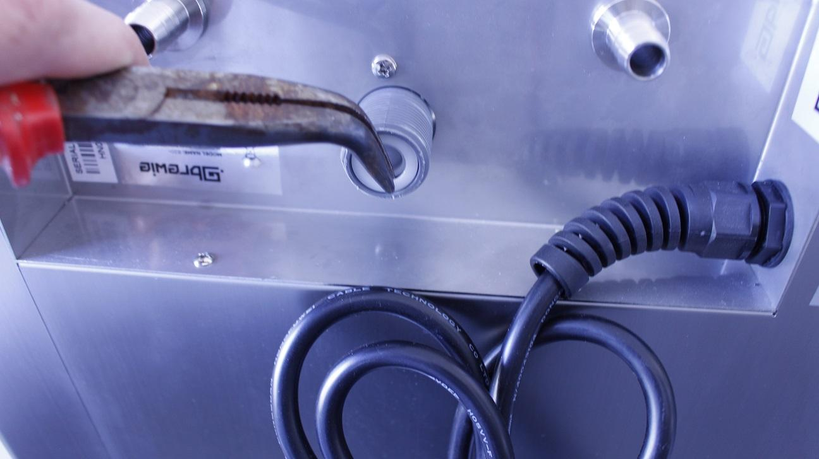

The check valve can be easily removed.

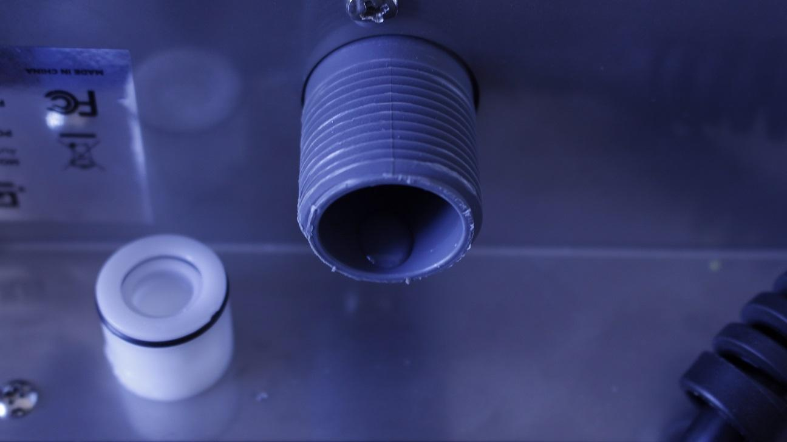

Reassemble consists of the same steps in reverse.